

**Project Report**

**HOSTEL MANAGEMENT SYSTEM**

**Submitted By:**

**CS C (2019-2023)**

RUBHAV MAHENDRU-19070122142

SAIF KHAN-19070122146

SAMARTH TYAGI-19070122149

**SYMBIOSIS INSTITUTE OF TECHNOLOGY**

**(A CONSTITUENT OF SYMBIOSIS INTERNATIONAL UNIVERSITY)**

Pune

2019-2020

WHAT ALL DO WE COVER IN HOSTEL MANAGEMENT SYSTEM?

ATTENDANCE RECORDS OF STUDENTS.

ADDITION OF NEW RECORDS.

UPDATING ATTENDANCE AS SOON AS IT IS MARKED ON THE ADMIN PORTAL.

DISPLAYING THE RECORDS UPON QUERY WITH THE CORRECT USER-ID.

WHY HOSTEL MANAGEMENT SYSTEM

* For the past few years the number of educational institutions are increasing rapidly.
* Thereby the number of hostels are also increasing for the accommodation of the students studying in this institution.
* This particular project deals with the problems on managing a hostel and avoids the problems which occur when carried manually

FLOWCHART

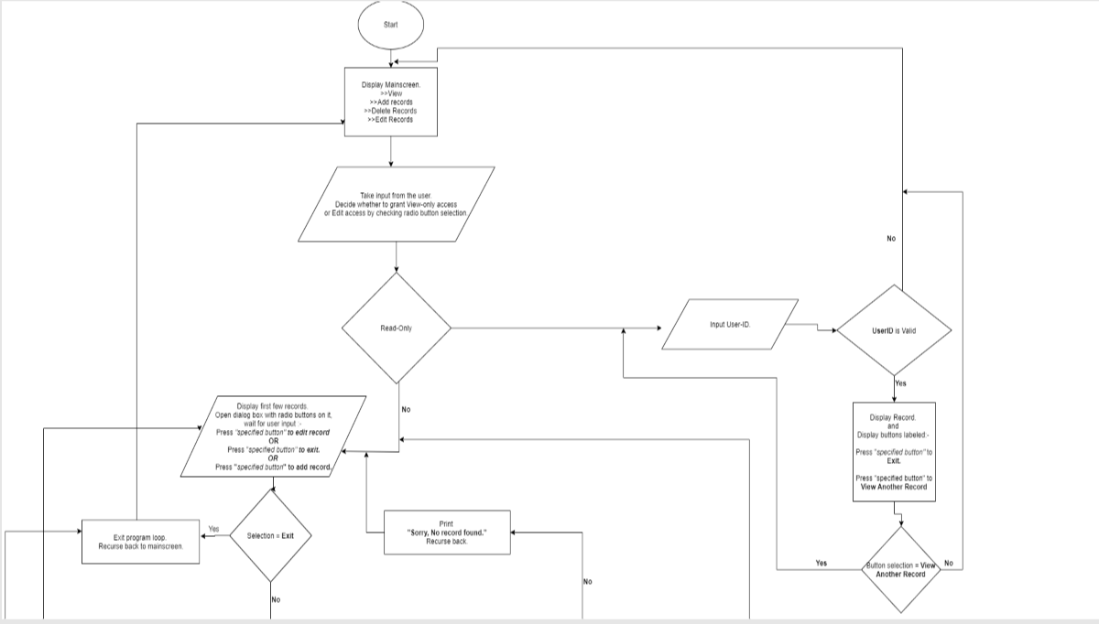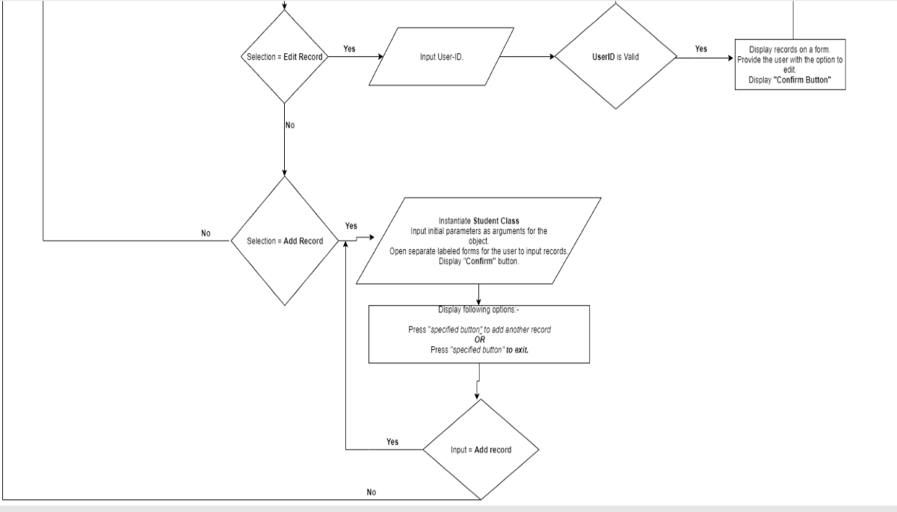

ALGORITM

STEP 1: START

STEP 2: display main contents

STEP 3:ask user which mode: read only or edit access

STEP 4:if edit access, options will display whether to edit and add record or exit.

STEP 5:in edit mode, user have to give user id which will be verified first, and then it can be edited.

STEP 6: in add record mode, separate forms will be opened to for user to add records.

STEP 7:if exit, then go back to main menu.

STEP 8:if read only mode: user have to type user id which will be verified.

STEP 9:if correct user id, display records and another options to exit and view another record.

STEP 10:if incorrect user id, go back to main menu STEP11:exit

CODE:



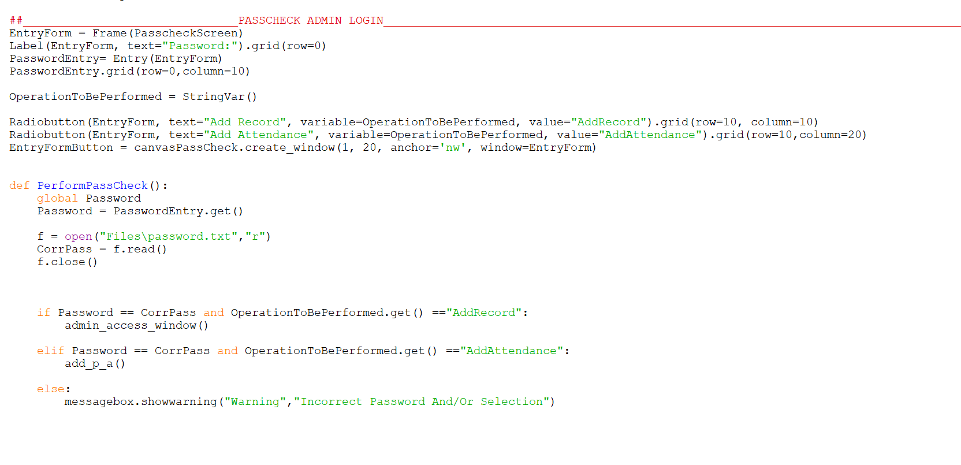

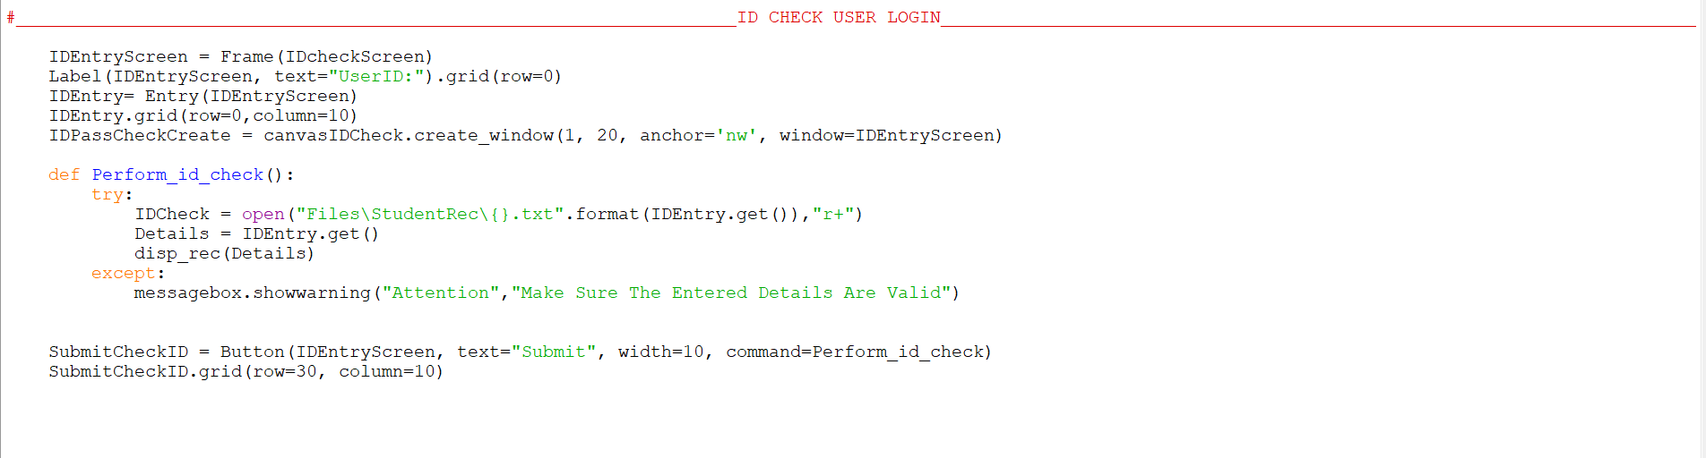

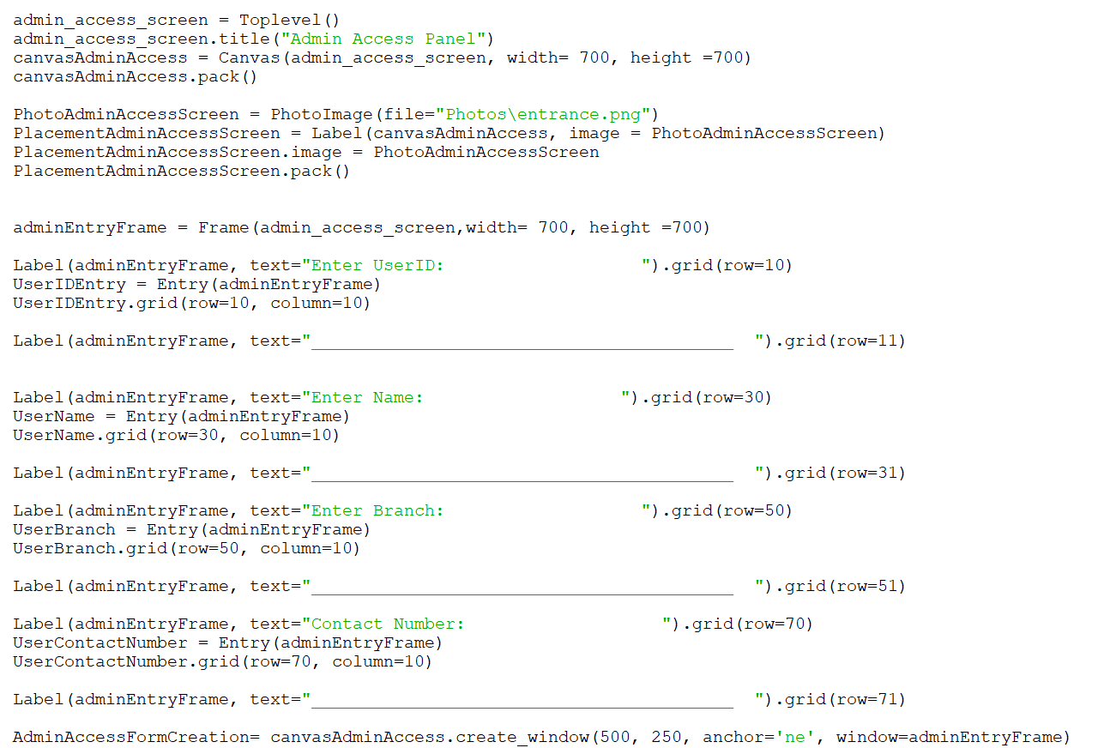

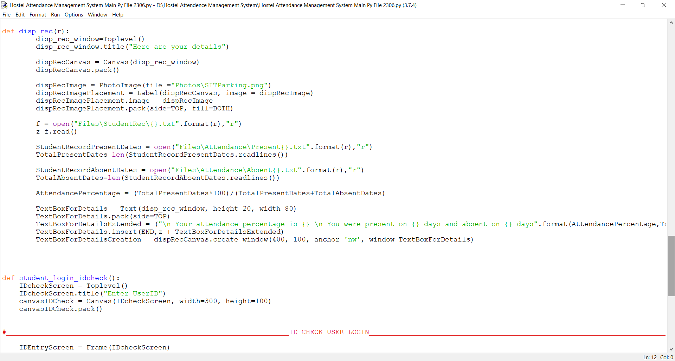

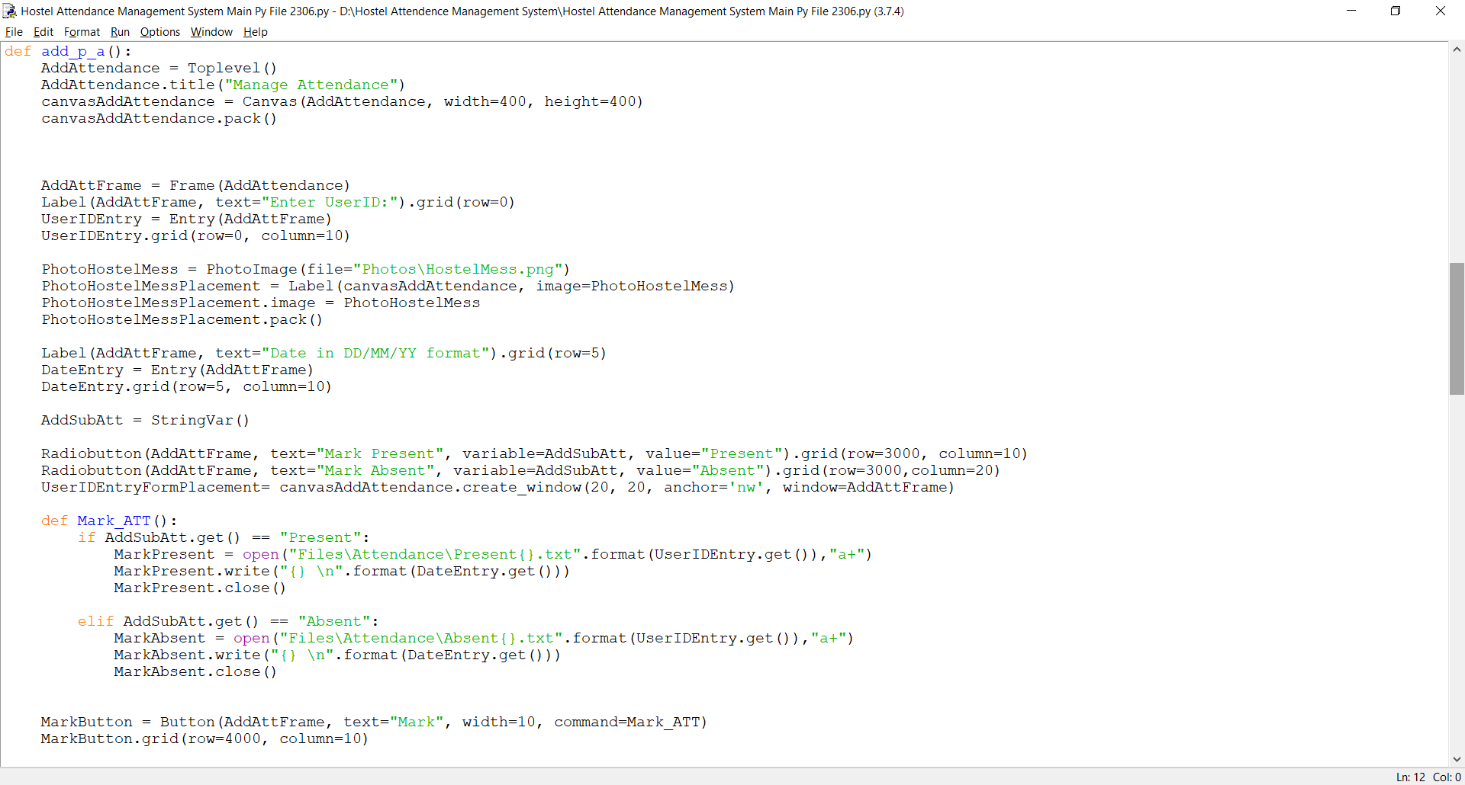

OUTPUTS:

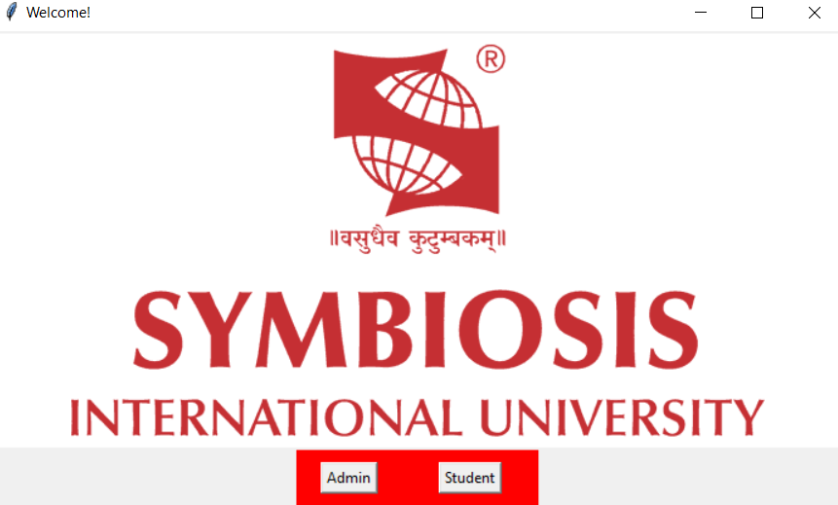

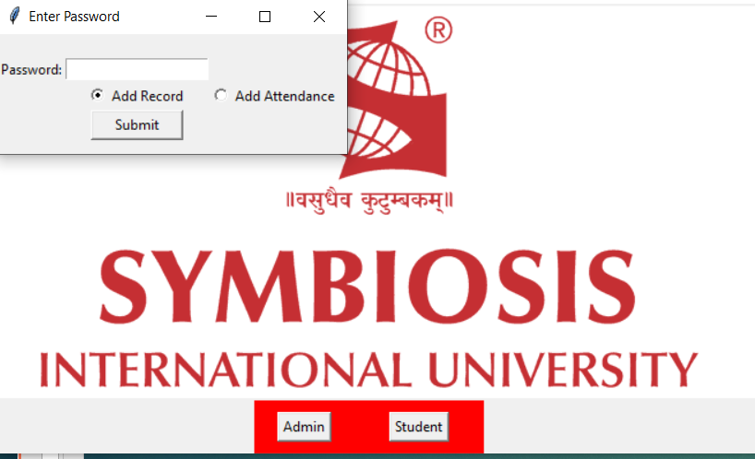

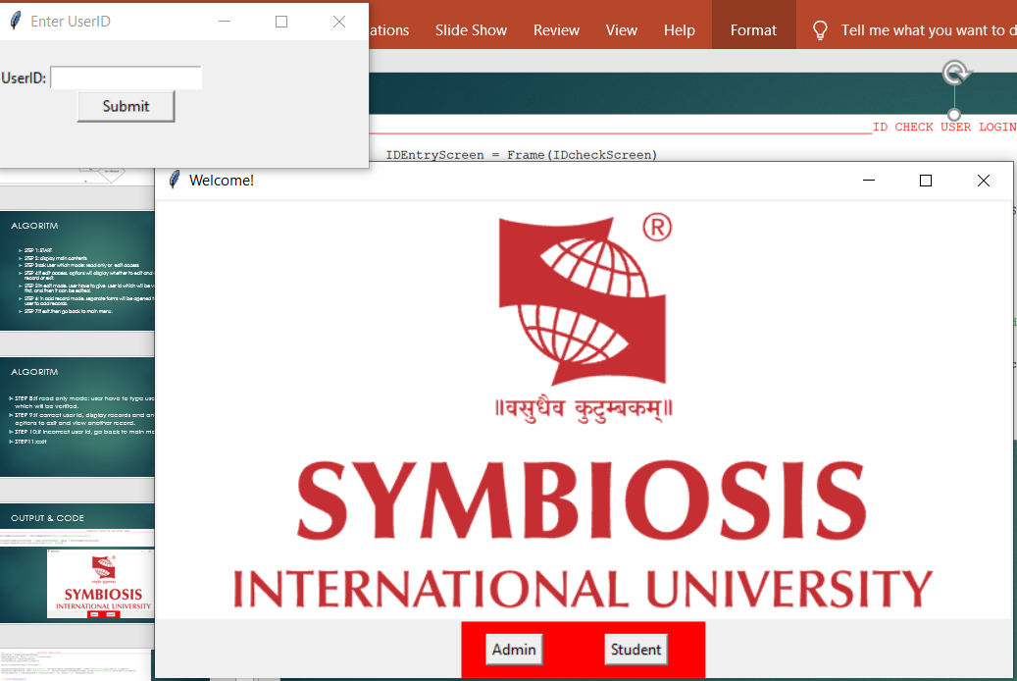

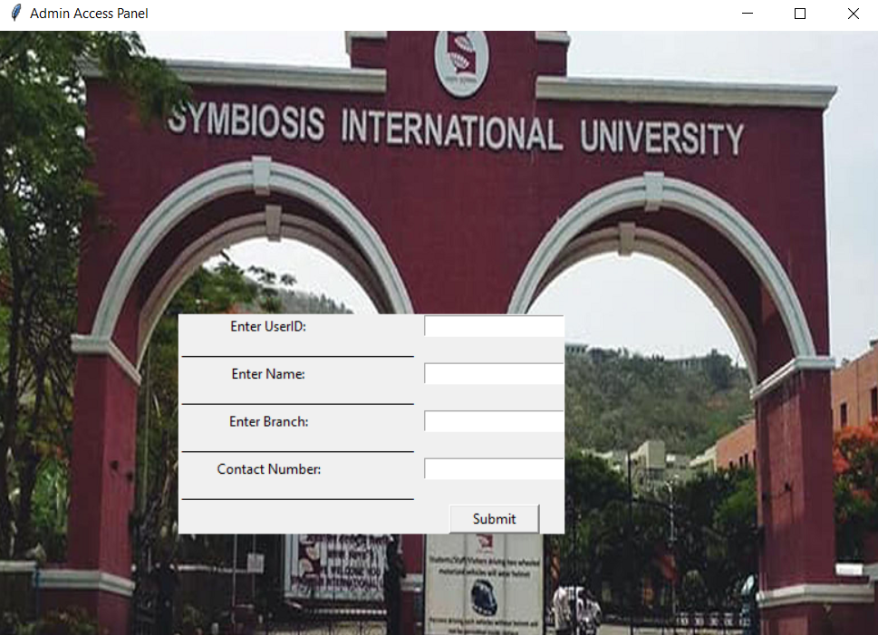

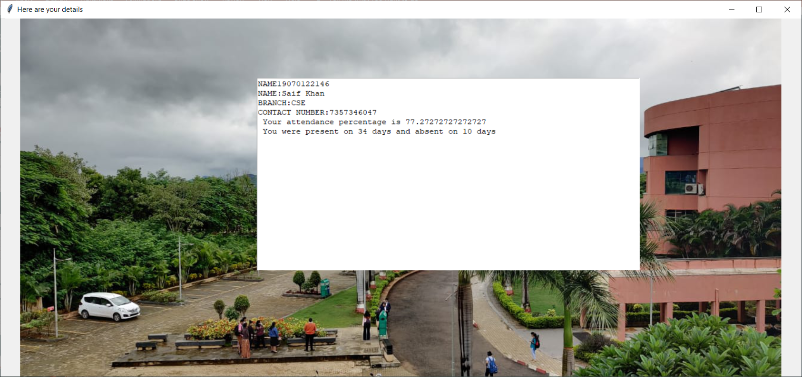

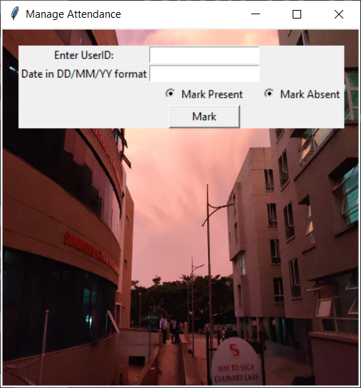

Thank you